H.T No
Regulations:
A19

Sreenidhi Institute of Science and Technology
(An Autonomous Institution)
Code No: 7R103 Date: 09-Oct-2020 (FN)

M.Tech I-Year I-Semester External Examination, October - 2020 (Supplementary)
ADVANCED COMPUTER NETWORKS (CNIS)

Time: 2 Hours Max.Marks:70

Note: a) No additional answer sheets will be provided.
b) All sub-parts of a question must be answered at one place only, otherwise it will not be valued.
c) Missing data can be assumed suitably.

ANSWER ANY 5 OUT OF 8 QUESTIONS. EACH QUESTION CARRIES 14 MARKS.

1. | a) | Explain the different types of Physical Media transmission. | [7M]
 | b) | Draw an ATM Model and discuss its Protocol Structure with advantages. | [7M]
2. | a) | The message 11001001 is to be transmitted, using CRC error detection Algorithm.  Assuming the CRC polynomial to be n³+1, determine the message that should be transmitted. If the second leftmost bit is corrupted, Show that it is detected by the receiver. | [7M]
 | b) | Explain Ethernet Technologies in detail? | [7M]
3. | a) | Consider the following network.  i) Find the least-cost path between the two servers, using Dijkstra’s algorithm.  ii) Show an iteration graph as the least-cost path is developed.  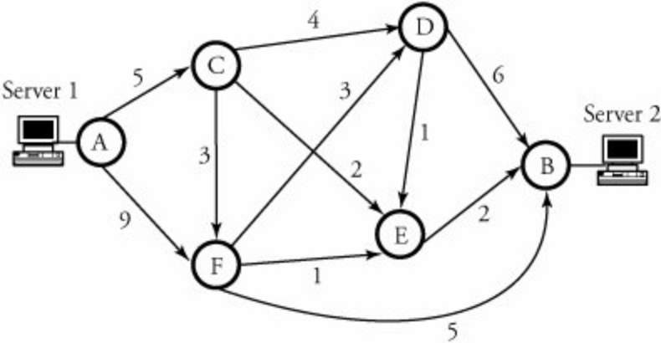 | [7M]
 | b) | With neat diagram, explain four types of BGP packets. | [7M]
4. | a) | What is IPv4 Protocol? In IPv4, fragmentation reassembly is done at the endpoints, rather than at intermediary routers. Does IPv4 permit routers to reassemble packets? What is an important reason why reassembly be done at the end points? | [7M]
 | b) | Write the principles of network applications. | [7M]
5. |  | Write a brief note on:
 | a) | Wireless sensor Networks. | [7M]
 | b) | Mobile ad-hoc Networks. | [7M]
6. | a) | What is a Virtual Private Network? What are the advantages of using VPN to an organization? | [7M]
 | b) | Explain the over view of IP Telephony with its basic components. | [7M]
7. | a) | Give the history of computer networking and the internet. | [7M]
 | b) | Write short notes on 7-layer OSI model. | [7M]
8. | a) | Describe the multiple access protocols. | [7M]
 | b) | Explain error correction techniques. | [7M]

-- 00 -- 00 –

